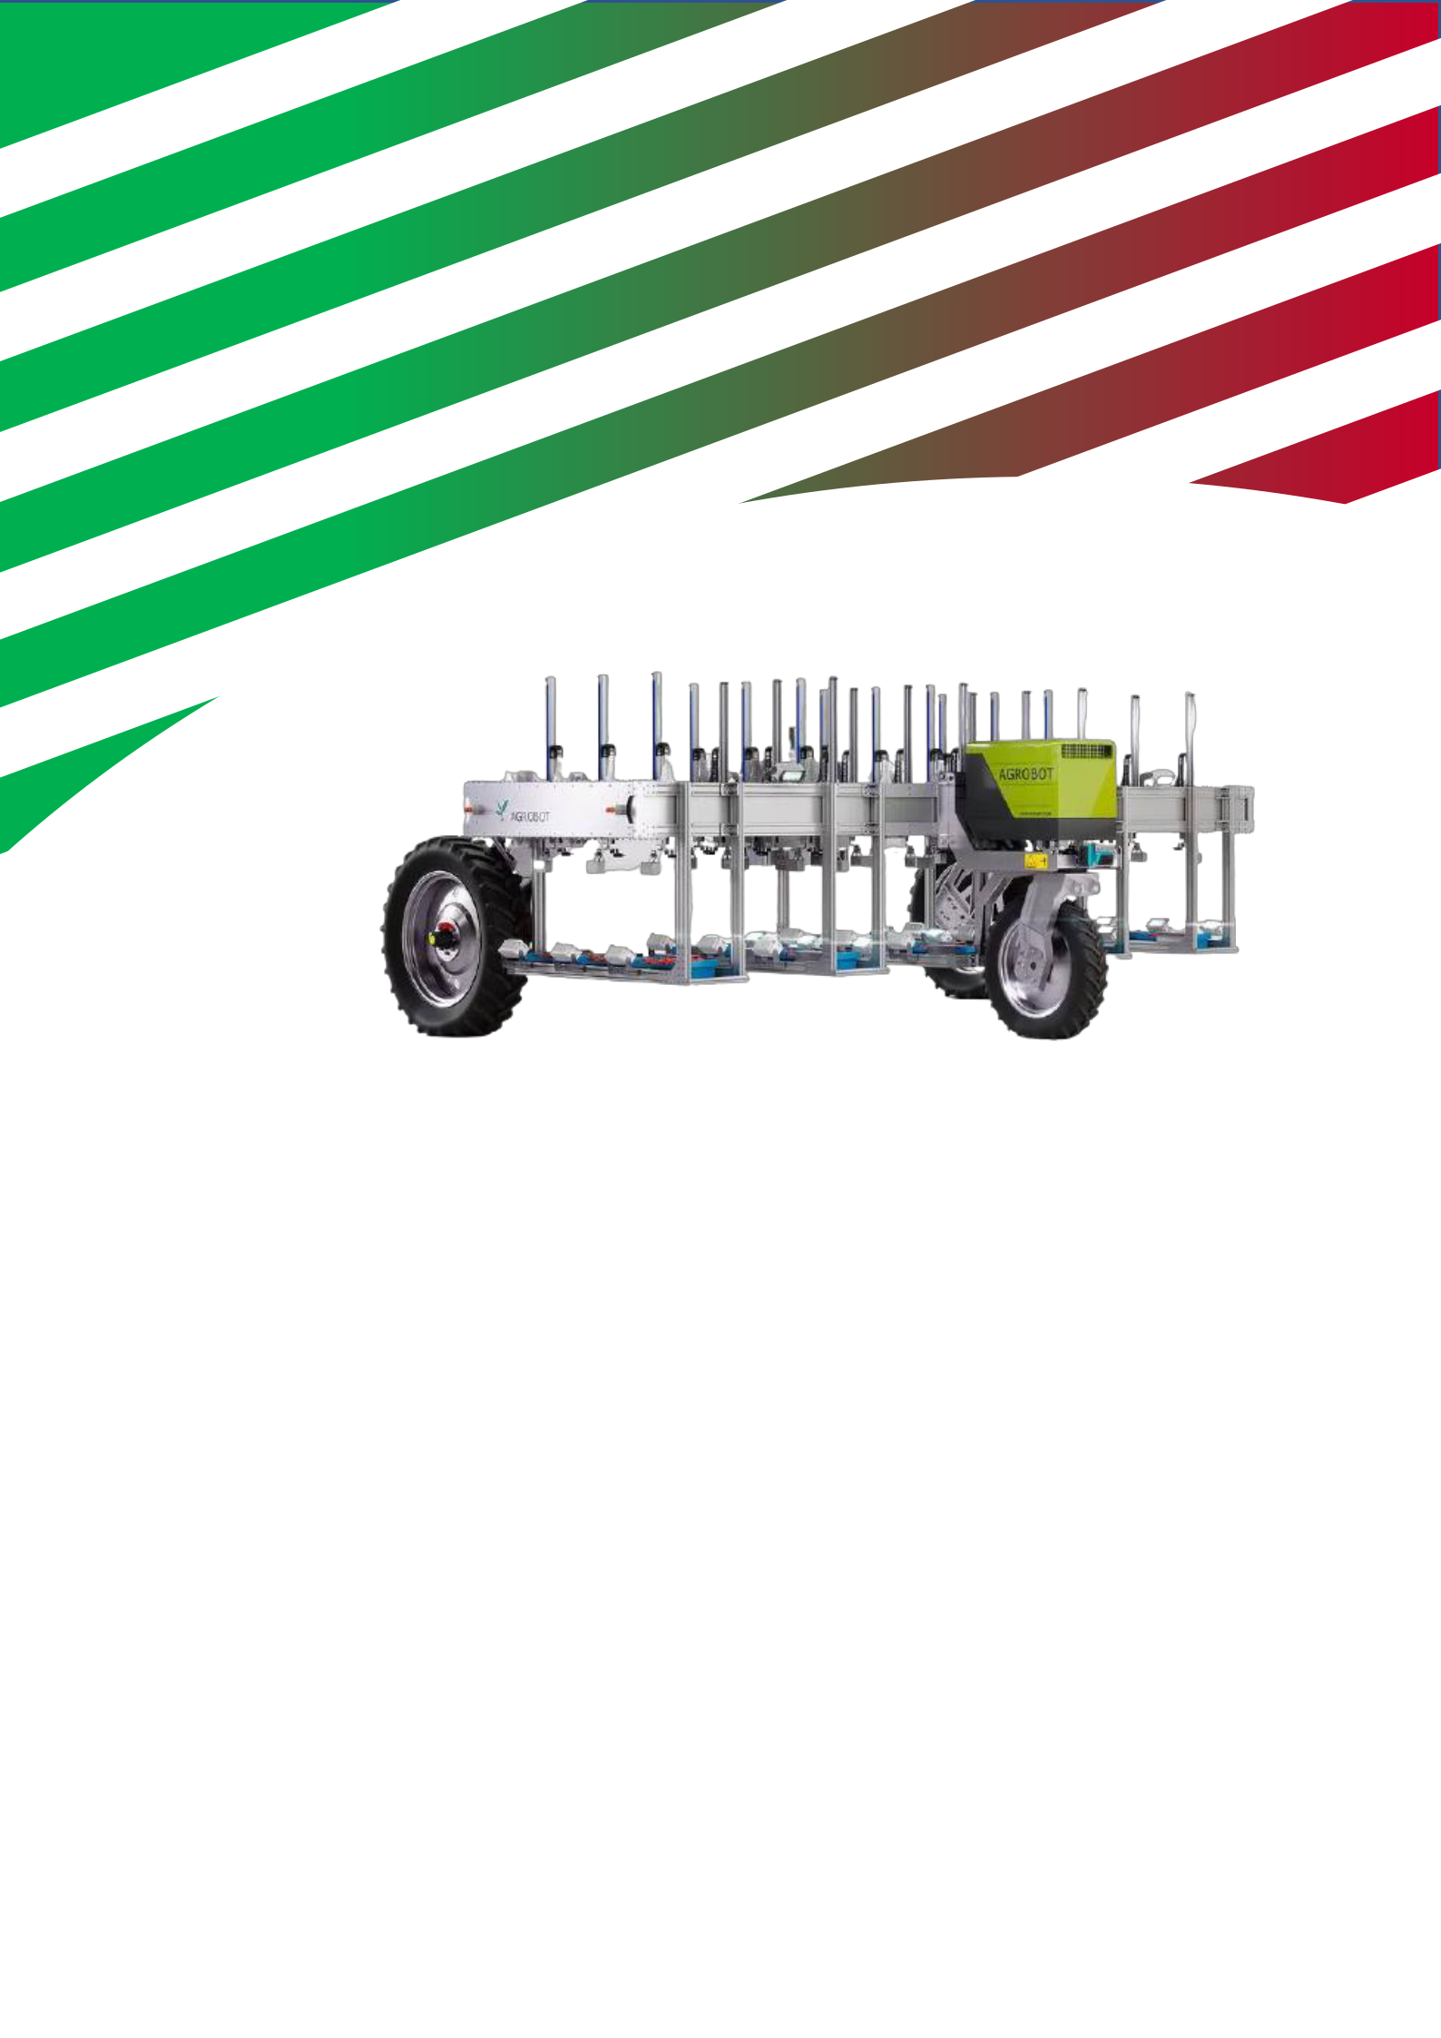

CONTEST RULEBOOK

Agrobot Gantry

Contents
1. Washed 3
Salad 3
Carrot 3
Beetroot 3
Radish 3
2. The field 5
Planter 5
Harvest bins 6
Competition field 7
3.Agrobot Gantry 9
Physical conditions 9
Contest conditions 11
4. The competition 13
Before the match round 13
Scoring 13
During the game 13
After the match 13

1. Crops
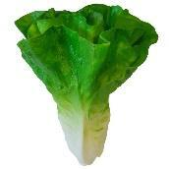

Salad

One of the crops to be harvested is a head of lettuce as shown in Figure 1.

This head of lettuce will only come above the ground with the top part.

https://decofoodshop.nl/product/namaak-krop-sla/ length: 17 cm
Diameter: 16 cm

Figure 1: Head of lettuce
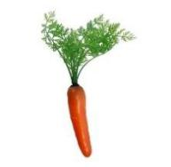

Carrot

One of the crops to be harvested is a carrot as shown in Figure 2. This carrot will only come above the ground with the upper part.

https://decofoodshop.nl/product/namaak-root/ length: 30 cm

Diameter: 3 cm

Figure 2: Carrot


Beetroot

One of the crops to be harvested is a beetroot as shown in Figure 3. This beetroot will only come above the ground with the top part.

https://decofoodshop.nl/product/namaak-biet/ | Figure 3: Beetroot

Length: 30 cm

Diameter: 9 cm

Radish

One of the crops to be harvested is a radish as shown in Figure 4. This radish will only come above the ground with the top part.

https://decofoodshop.nl/product/nep-radishes/

Length: 18 cm

Diameter: 2 cm

Figure 4: Radish


2. The field

Planter

The field will consist of 4 planters. The planters measure 100x100x20 centimeters and contain 9 pixels as shown in Figure 5. The width of the planter corresponds to the working width of the original gantry of previous projects.

The sides of the planter will have to be sawn off and metal angles placed.

Otherwise, the planter will fall outside the working area of the Agrobot Gantry.
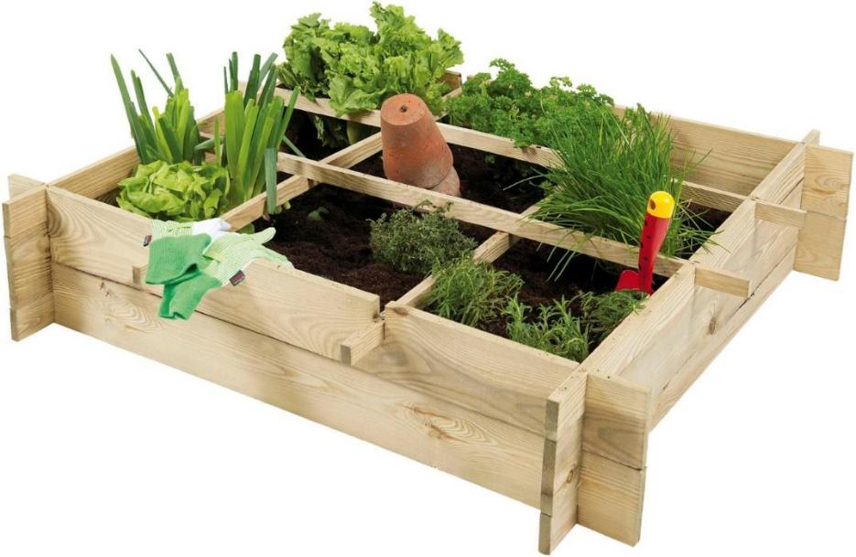

Figure 5: Planter

Each pixel will have a separate crop. Depending on the type of crop, this can be 1 or more plants. The crops will be distributed across the planters in a random pixel pattern. A pixel will be approximately 30x30 centimeters.

Link to planter:

https://buitengoed.nl/artikel/12289/woodvision-minigarden-vierkante-meter-afm-100-x-100-x-20- cm-geimpregneerd-grenen.html?dfw_tracker=23864-

WVW26060&gclid=CjwKCAjw1ICZBhAzEiwAFfvFhAcV20bb2iRDTY7QvYTohtNXFGMXkW6JrFavcCjy7ZU3sZ4kVG7zxoC17E

Harvest bins

The intention is that the crop is drawn and placed in different harvesting bins. These harvest bins measure 40cm by 30cm by 17cm. Because there are 4 different crops, 4 different harvest bins are also placed. A yellow harvesting bin as shown in Figure 7, a red harvesting bin as shown in Figure 6, a green harvesting bin as shown in Figure 9 and a blue harvesting bin as shown in Figure 8. crop in which color harvest bin is placed. The team can decide for themselves where the harvest bins will be placed. The harvest bins have different colors so that they can be distinguished by vision or by sensors.
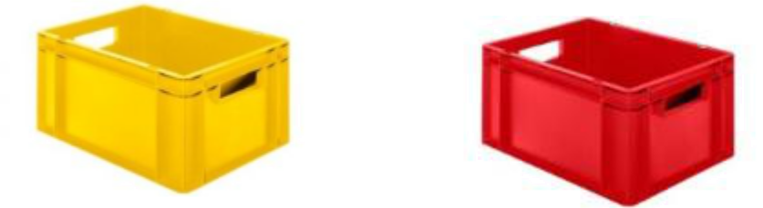

Figure 7: Yellow Harvest Bin Figure 6: Red harvest bin
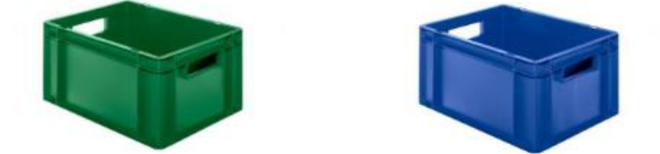

Figure 9: Green harvest bin | Figure 8: Blue Harvest Bin

Link yellow box:

https://www.norah.nl/plastic-stacking-bin-colour-yellow-closed-with-open-handles-size-40-x-30-x-17-cm.html

Link red box:

https://www.norah.nl/plastic-stacking-bin-colour-red-closed-with-open-handles-size-40-x-30-

x-17-cm.html

Link green box:

https://www.norah.nl/plastic-stacking-bin-color-green-closed-with-open-handles-size-40-x-30-x-17-cm.html

Link blue bin:

https://www.norah.nl/plastic-stacking-bin-color-blue-closed-with-open-handles-size-40-

x-30-x-17-cm.html

Competition field

The competition field will consist of 4 planters as shown in Figure 10. Each team will bring their own planter to the game and a random pixel pattern will be created by the teams as shown in Figure 11. Below is a schematic representation view of the competition field including dimensions. At the beginning or end of the harvest bins will be placed in which the crops must be placed.
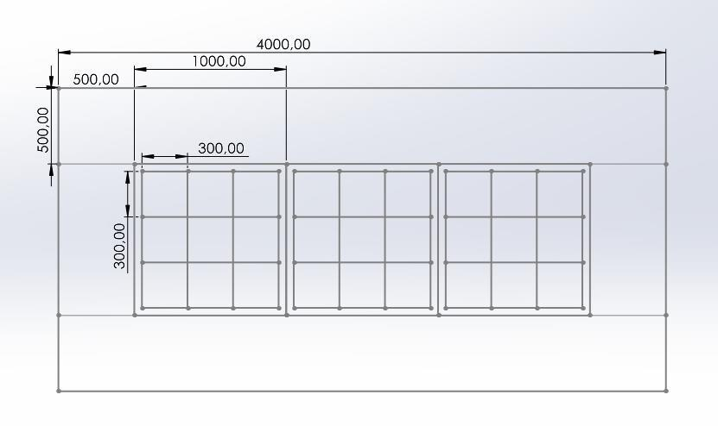

Figure 10: Schematic field overview

Crop 1
Crop 2
Crop 3
Crop 4
Driving Path

3.Agrobot Gantry

There are several conditions that the Agrobot Gantry must meet. These conditions are divided into physical conditions and competition conditions.

Physical conditions

Maximum dimensions of the Agrobot Gantry have been determined. This has been determined based on the work area of Agrobot Gantry's previous models. These dimensions as shown in Figure 12 exactly match the size of the planters and the field. This must be taken into account in the design and realization. In Table 1 all physical conditions of the Agrobot Gantry can be found.
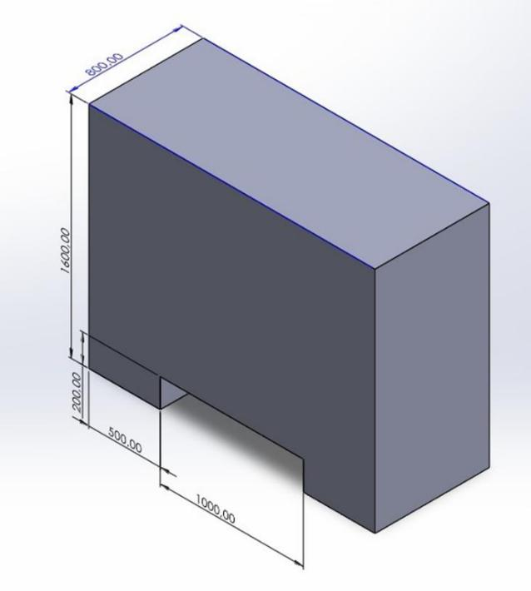

Figure 12: Dimensions Agrobot Gantry

Table 1: Agrobot Gantry Physical Conditions

Physical conditions Agrobot Gantry
Dimensions | The agrobot must fall within the
 | prescribed dimensions.
 | Max 1.6 meters high.
 | Max 1.3 meters deep.
 | Max 2.0 meters wide.
Weight | The agrobot may weigh a maximum of 100 kg without crops

Contest conditions

During the competition, there are several conditions that the Agrobot Gantry must meet.

These different conditions can be found in Table 2.

Table 2: Contest conditions Agrobot Gantry

Contest conditions Agrobot Gantry
displacement | The Agrobot Gantry must be able to
 | move at least over all 4 planters
Positioning | The Agrobot Gantry must be able to determine its position with a wireless network that is to be built and, based on this, move along the predetermined driving path
Harvest | The Agrobot Gantry must be able to pick up
 | individual crops using a suitable gripper and place them in a harvest bin
Image recognition | The Agrobot Gantry must move to the correct
 | position of a crop to be harvested using
 | image recognition software

4. The competition

Before the match round

The team that has to harvest may place the crops themselves in the first bin and the other teams must fill in the other bins. These crops will be partly placed under the ground. A total of 36 crops will be placed at random by the other teams.

The team that has to harvest can decide for themselves in their chosen crop box where the crops are placed. The other teams may then place the crops in front of their designated crop bin.

The team can then place the 4 different harvest bins themselves. The team must tell in advance which color harvesting bin they will use for which crop. This is included in the scoring.

Scoring

1 point: For every crop they harvest.

2 points: For each crop they harvest and place in a Harvest Bin

3 points: For each crop they harvest and place in the pre-arranged color harvest bin.

During the game

Each team gets 15 minutes to harvest as many crops as possible and place them in the Harvest Bin. During the race, the Agrobot may be rested and possibly operated manually to return to the starting point. Crops may not be placed in the ground again and if the agrobot gets stuck, the agrobot may possibly be picked up and placed in the starting position.

After the match

The team with the most points within 15 minutes wins. If it appears that there is a tie between 2 teams, the time of the last point will be considered. The team that reaches the last point the fastest wins.

